Stock Market Analysis System using Quick Sort
Aim
To analyze how Quick Sort efficiently sorts stock prices in real-time stock market systems using the Divide and Conquer strategy.

Problem Statement
A stock market platform continuously receives stock prices that must be sorted quickly for market analysis. Since thousands of price updates occur every second, an efficient sorting algorithm is required. Quick Sort provides high average performance but requires careful pivot selection to avoid poor performance.

Algorithm
- Select a pivot element.
- Partition the array so that:
  - Smaller elements are placed before the pivot.
  - Larger elements are placed after the pivot.
- Recursively apply Quick Sort to the left sub-array.
- Recursively apply Quick Sort to the right sub-array.
- Continue until every sub-array contains one or zero elements.

Divide and Conquer Principle
Quick Sort follows Divide and Conquer by:
- Dividing the array into two partitions around a pivot.
- Solving each partition recursively.
- Combining the sorted partitions automatically to obtain the final sorted array.

Case Study Analysis
Suppose the stock prices are:
520 480 600 450 700 650 500
Choose pivot = 500
After partition:
480 450 500 520 700 650 600
Left Part:
480 450
Right Part:
520 700 650 600
Each part is recursively sorted until the complete array becomes:
450 480 500 520 600 650 700

Pivot Selection Issues
Best Pivot
- Middle element
- Random pivot
- Median-of-three pivot
Advantages:
- Balanced partitions
- Faster execution
- Lower recursion depth

Poor Pivot
Always selecting:
- First element
- Last element
When data is already sorted:
100 200 300 400 500
Results in highly unbalanced partitions.
Worst-case complexity becomes:
O(n²)

Worst Case Scenario
Occurs when:
- Data is already sorted.
- Data is reverse sorted.
- Duplicate elements dominate.
- Poor pivot selection.
This increases recursion depth and execution time.

Optimized Solution
Instead of selecting the last element as the pivot:
Use:
- Random Pivot
- Median of Three
Benefits:
- Prevents worst-case behavior.
- Produces balanced partitions.
- Improves average performance.
- Better suited for continuously changing stock prices.

Time Complexity
Case | Complexity
Best Case | O(n log n)
Average Case | O(n log n)
Worst Case | O(n²)

Space Complexity
Average : O(log n)

Worst : O(n)

Advantages
- Very fast for large datasets.
- Efficient cache performance.
- In-place sorting.
- Widely used in real-time systems.
- Excellent average performance.

Disadvantages
- Worst-case O(n²).
- Recursive implementation.
- Performance depends on pivot selection.
- Not a stable sorting algorithm.

Program
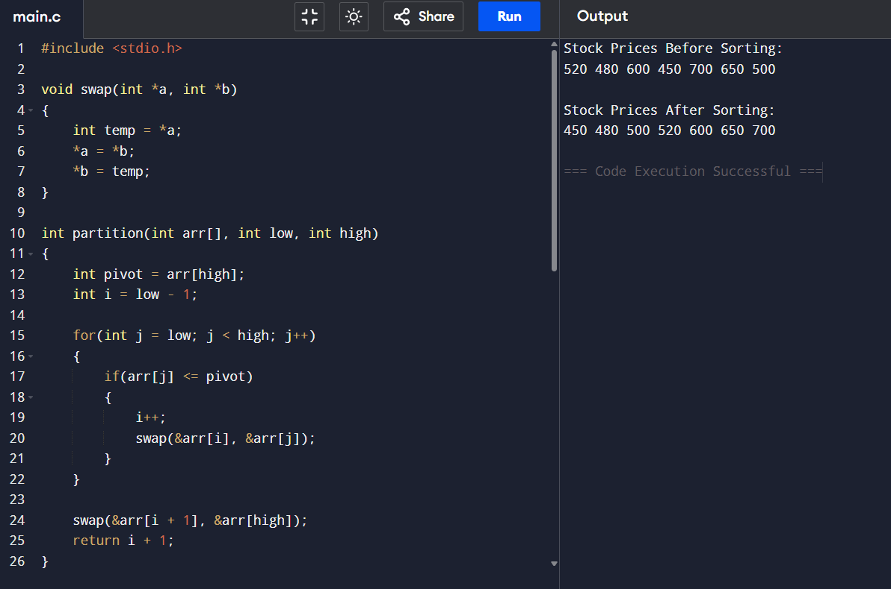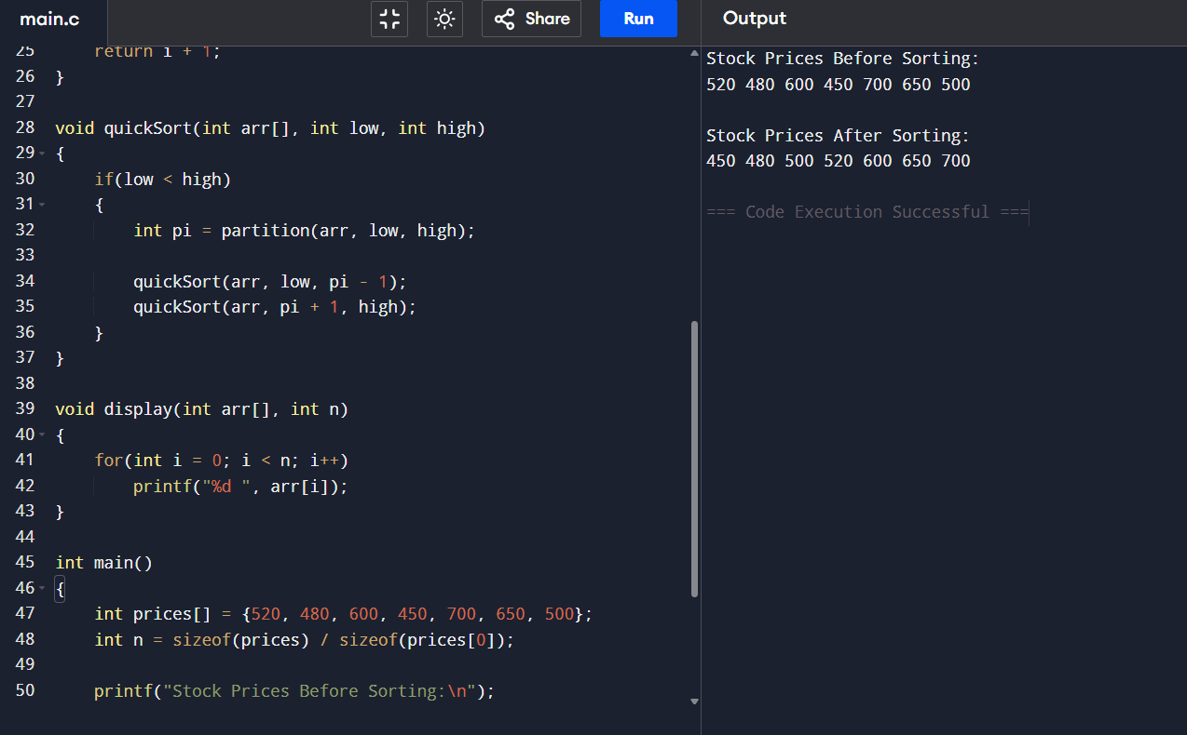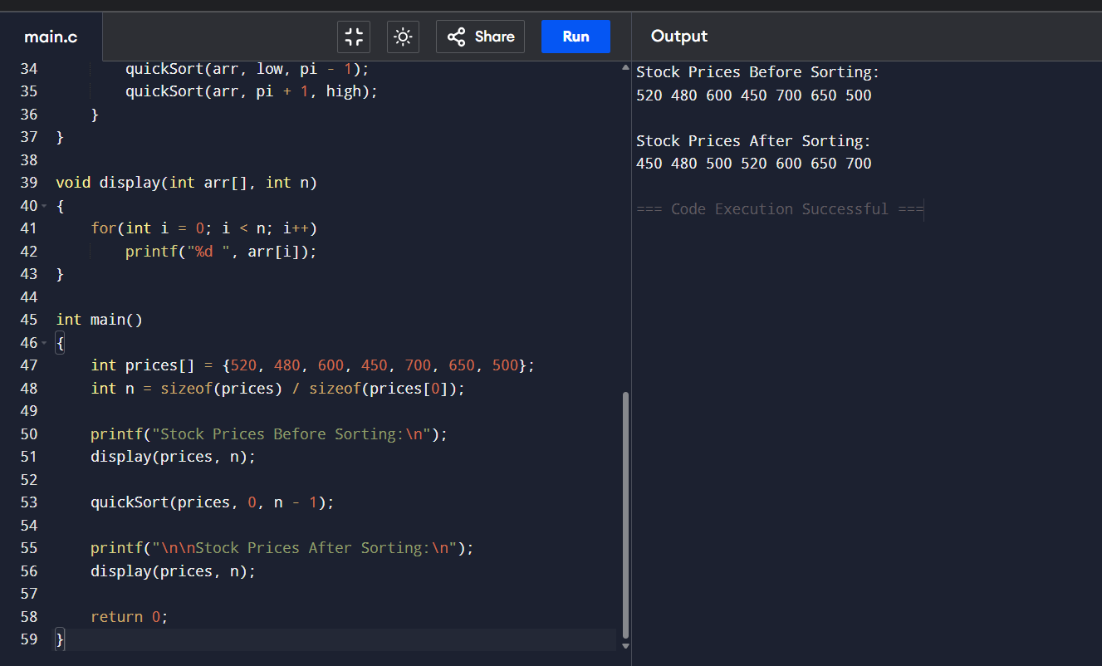

Conclusion
Quick Sort is an efficient sorting algorithm for stock market analysis because it uses the Divide and Conquer technique to sort large datasets quickly. Its average-case complexity of O(n log n) makes it suitable for real-time stock price processing. However, poor pivot selection can lead to the worst-case O(n²) complexity. Using optimized pivot selection methods such as Random Pivot or Median-of-Three improves performance and makes Quick Sort more reliable for dynamic stock market applications.

